DIVIDE AND CONQUER METHOD

- A divide-and-conquer algorithm works by recursively breaking down a problem into two or more sub-problems of the same or related type, until these become simple enough to be solved directly.
- The solutions to the sub-problems are then combined to give a solution to the original problem.
- This technique can be divided into the following three parts:

- Divide: This involves dividing the problem into some sub problem.

- Conquer: Solve the Sub problem by calling recursively until all the sub problems solved.

- Combine: The Sub problem solved so that we will get find problem solution.

Divide/Break
- This step involves breaking the problem into smaller sub-problems.
- Sub-problems should represent a part of the original problem.
- This step generally takes a recursive approach to divide the problem until no sub-problem is further divisible.
- At this stage, sub-problems become atomic in nature but still represent some part of the actual problem.

Conquer/Solve
- This step receives a lot of smaller sub-problems to be solved.
- Generally, at this level, the problems are considered 'solved' on their own.

Merge/Combine
- When the smaller sub-problems are solved, this stage recursively combines them until they formulate a solution of the original problem.

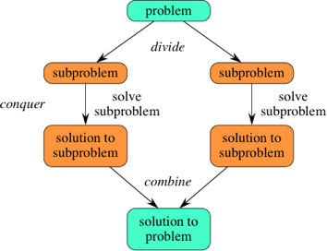
CONTROL ABSTRACTION OF DIVIDE AND CONQUER
- A control abstraction is a procedure whose flow of control is clear but whose primary operations are specified by other procedures whose precise meanings are left undefined.
- The control abstraction for divide and conquer technique is DANDC(P), where P is the problem to be solved.
DANDC (P)
{
if SMALL (P) then return S (P);
else
{
Divide P into smaller instances P₁, P₂, …. P_{k}, k≥1
Apply DANDC to each of these sub problems;
Return (COMBINE (DANDC (P₁), DANDC (P₂),…., DANDC (P_{k})) ;
}
}
- SMALL(P) is a Boolean valued function which determines whether the input size is small enough so that the answer can be computed without splitting.
- If this is so function ‘S’ is invoked otherwise, the problem ‘P’ is divided into smaller sub problems.
- These sub problems P₁, P₂, . . . , P_{k} are solved by recursive application of DANDC.

